TC-DISP-019
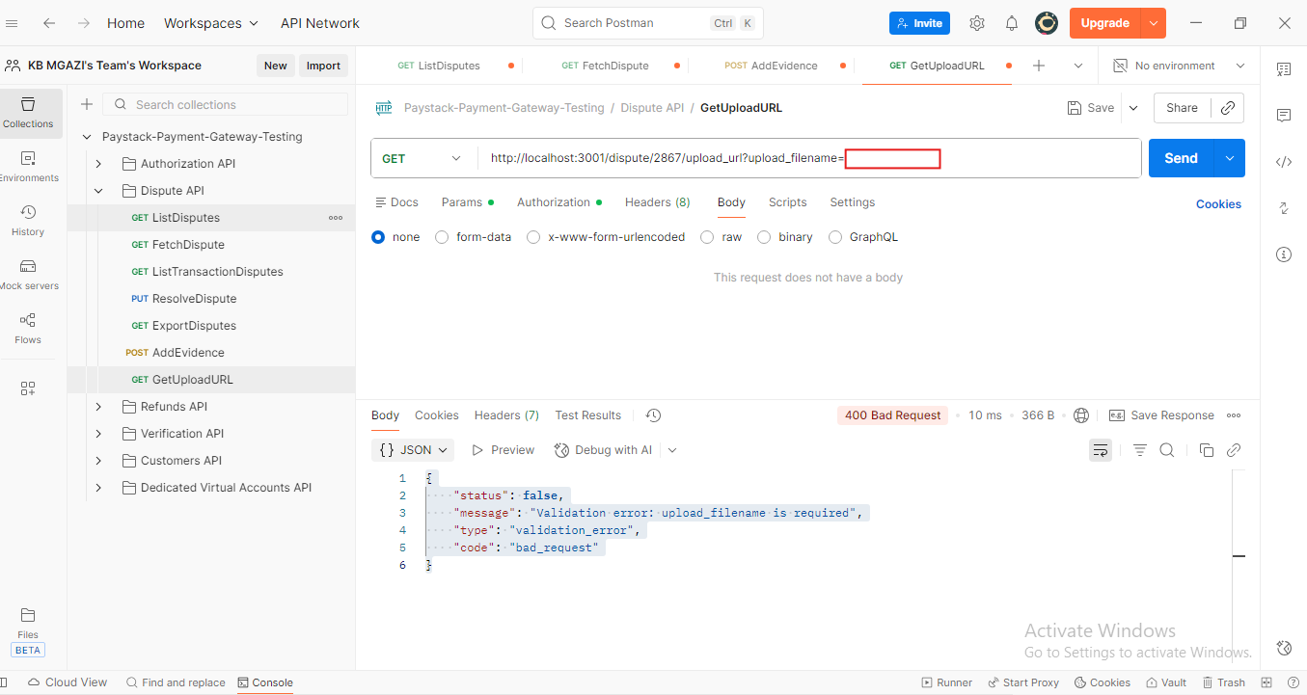Response:
{
"status": false,
"message": "Validation error: upload_filename is required",
"type": "validation_error",
"code": "bad_request"
}

